12.23:
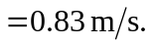

One could certainly walk that fast.

